
SYMBIOSIS INSTITUE OF TECHNOLOGY
(Established under section 3 of the UGC Act 1956) Re-accredited by NAAC with “A” Grade

Name : Aniruddha Pratap Singh
Year: AY 25-29
PRN: 25070122247
Semester: 3

ASSIGNMENT No: 14
TITLE: Write a Java program to demonstrate exception handling using try and catch blocks, nested and multiple try-catch blocks
Problem Statement :
Write a Java program to demonstrate exception handling using try and catch blocks, nested and multiple try-catch blocksTheory:
Exception handling prevents abnormal termination of programs due to runtime errors. The try block contains code that may generate exceptions, while catch blocks handle specific exceptions. Nested and multiple try-catch structures allow complex error management. Exception handling improves software reliability and user experience by gracefully managing unexpected situations..

Program :
public class ExceptionDemo {

public static void main(String[] args) { try {
int arrr[] = {10, 20, 30}; try {
int result = arrr[5];
System.out.println(result);

} catch (ArrayIndexOutOfBoundsException e) { System.out.println("Nested Catch: Array Index Out Of Bounds");
}

int num = 10 / 0; System.out.println(num);

} catch (ArithmeticException e) {

System.out.println("Outer Catch: Arithmetic Exception");

} catch (Exception e) { System.out.println("General Exception");
}

System.out.println("Program Continues...");

}

}

Output :
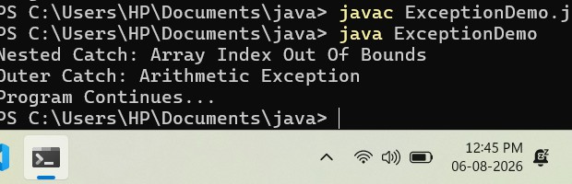

Exercise 1: Create an ATM program handling invalid withdrawal amount using try-catch
Program :

class ATM {
public static void main(String[] args) { int balance = 10000;
int withdrawal = 12000;
try {
if (withdrawal <= 0) {
throw new Exception("Withdrawal amount must be greater than
zero.");
}
if (withdrawal > balance) {
throw new Exception("Insufficient balance.");
}

balance = balance - withdrawal;

System.out.println("Withdrawal Successful."); System.out.println("Remaining Balance: Rs. " + balance);

} catch (Exception e) {
System.out.println("Transaction Failed: " + e.getMessage());
}
System.out.println("ATM transaction completed.");
}
}

Output:
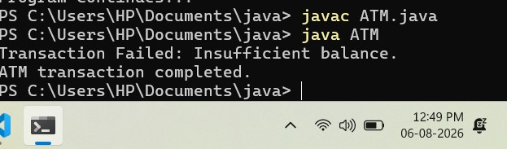

Exercise 2. Develop a Vehicle Insurance System where child insurance classes access parent vehicle information using the super keyword.
Source code:
import java.util.Scanner; public class OnlineShopping {
public static void main(String[] args) { Scanner sc = new Scanner(System.in); try {
System.out.print("Enter product quantity: "); int quantity = sc.nextInt();
if (quantity <= 0) {
throw new Exception("Product quantity must be greater than zero.");
}
System.out.println("Product quantity is valid."); System.out.println("Quantity: " + quantity);
} catch (Exception e) {

System.out.println("Invalid Quantity: " + e.getMessage());

}

sc.close();
}
}

Output:

